Save Our Seeds NOTICE, October 5th 2009 haerlin@zs-l.de

Romania introduces labelling thresholds for GMO in non-GM seeds against the recommendation of the European Union’s Food and Veterinary Office – Inspection mission

Excerpts from the Inspection Report:
(Available in English, French and German at http://ec.europa.eu/food/fvo/rep_details_en.cfm?rep_id=2177)
MAFRD [Romanian Ministry for Agriculture] order No 631 of 2006 on control and certification of seed quality provides for the testing of non GM varieties which can be contaminated with GM.
MAFRD Order No 150 sets a labelling threshold of 0.9% GM in non GM soya bean seeds. In addition, limits of 0.9% GM in non GM seed are provided for in MARD Orders 147/2007 for sugar beet, 148/2007 for fodder species and 149/2007 for cereals and maize. No threshold for GMO in seed has yet been set at EU level for authorised GMO under Article 21 of Directive 2001/18/EC. This area is covered by harmonised Community rules and such thresholds may only be set by means of Community action. Therefore, Member States are prevented from introducing national provisions to regulate such thresholds.
The MAFRD informed the mission team that a new Ministerial Order on coexistence in seed production, which will include also the level of adventitious presence of GMO in non GM seeds, is being drafted. This new legislation will take into account Commission Recommendation 2003/556/EC, the opinion of the Scientific Committee on Plants, the results of a research project on co-existance of GM, conventional and organic crops and the views of the stakeholders. (…)
(2) Until such time as the threshold values for GMO in seed are set under Article 21 of Directive 2001/18/EC, ensure that national legislation on the adventitious presence of GMO in seed lots is brought into line with the practice of using the analytical limit of detection.
Not satisfactorily addressed. See section 5.2.
The existence of national legislation setting labelling thresholds for adventitious presence of GM material in non-GM seeds contravenes the provisions set out in Article 21.2 of Directive 2001/18/EC. In addition, until a EU labelling threshold for the adventitious presence of GMO seed in conventional seed is set, under Article 30.2 of Directive 2001/18/EC, the limit of detection should be used.
8 RECOMMENDATIONS
2 Ensure that national provisions do not regulate a labelling threshold for the adventitious presence of GMO seed in conventional seed lots. Such threshold shall be established at EU level under the procedure laid down in Article 30.2 of Directive 2001/18/EC, as provided by Article 21.2 of the same Directive.
3 Ensure that until a labelling threshold for the adventitious presence of GMO seed in conventional seed is set, under Article 30.2 of Directive 2001/18/EC, the limit of detection is used.

Excerpt from the Romanian Competent Authority Response
(url see above)
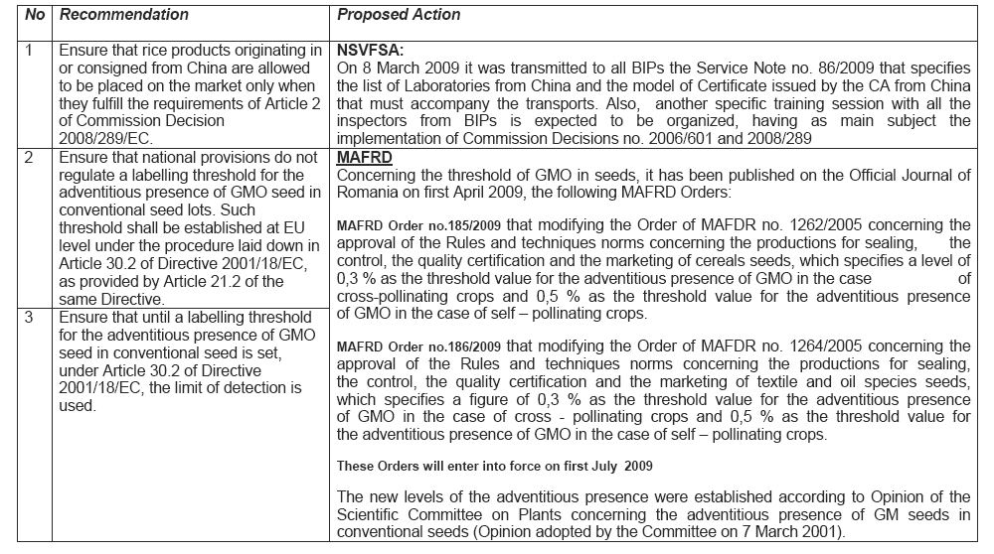

Conclusions and Action required
To our knowledge this labeling threshold is unique within the European Union’s national legislations. The Austrian Seed law, requiring 0 contamination of initial seed sample testing and only accepting 0,1% contamination in control tests, is the only other national legislation on seed thresholds. It had been contested by the EU Commission as well, to no avail. However, while the Austrian legislation implements the factual legal situation, which is that no GM seed can be sold unlabelled (unless a specific threshold is being set, as is the case for food and feed – 0,9% - but not for seed).
The Romanian legislation clearly contradicts the EU legislation. It sets a devastating precedence and should therefore urgently be legally challenged at national level with the aim of recalling this legislation or opening an opportunity to challenge it at the European Court of Justice.
Imports of soybeans as well as maize and their products from Romania should be exposed and challenged with reference to the uncertainty of their GM content. Seed imports from Romania should be banned, unless proven to comply with EU standards.
Written questions in the European Parliament asking about the Commissions legal reaction to the Romanian legislation would be helpful.
It would be helpful to elucidate the political background of the Romanian Agricultural Ministry’s action, including potential direct or indirect involvement of Monsanto or other seed companies.

